26 January 2017
Dear Parent / Carer,

I am writing to give you an update on the mock examinations that took place between January 5th and January 13th.

Your son / daughter’s results in these examinations will be shared with you on the monitoring report which you will receive on Friday February 3rd and you will be able to discuss the monitoring report in detail with subject teachers at the Parents’ Evening on March 9th. If, however, you have any concerns before then please do not hesitate to contact your son / daughter’s form tutor or subject teacher.

In addition to on-going assessment in lessons and through homework, performance in the mock examinations provides us with a very good indication of how students are performing to date in their A level courses. With this in mind, where students have achieved grade E (unless their target grade is E), U or two grades or more below their target grade in an examination, they will need to resit it on Thursday 2nd or Friday 3rd February. On Monday January 30th students will be informed of the exact date and time of the resit exam. They need to be aware that a large number of the exams will take place after school hours, in order to minimise the number of lessons that students would otherwise miss on those days. Subject teachers will discuss the outcomes of the resits with you at the forthcoming parents’ evening on Thursday March 9th.

I am sure that you will support your son / daughter in any way that you can in this process but please do not hesitate to contact the Sixth Form team or myself if you have any questions or concerns.

Kind regards,

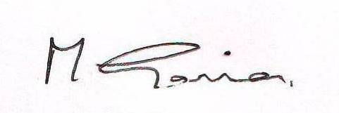

Miss M Gannon
Assistant Headteacher

