MIND MAPPING
INSTRUCTIONS:
The theory behind mind mapping is that it is a visual document which allows the reader to easily identify sections of the mind map and retrieve information quickly.

- The centre of the mind map should start with an image or a word that describes the topic.
- Each arm of the mind map stems from the centre. It must be a different colour.
- Any writing on each arm must be done in in CLEAR LETTERS.
- Do not write too much on each line – try to keep it to 1 or 2 words.
- Images can be attached to the arms of the mind map as an aid to remembering.
YOU WILL NEED:
- A Topic to revise! Your exercise books and text books that go with it.
- Some coloured pencils/pens (not felt tips or crayons!)
- PLAIN PAPER – A3 is best.

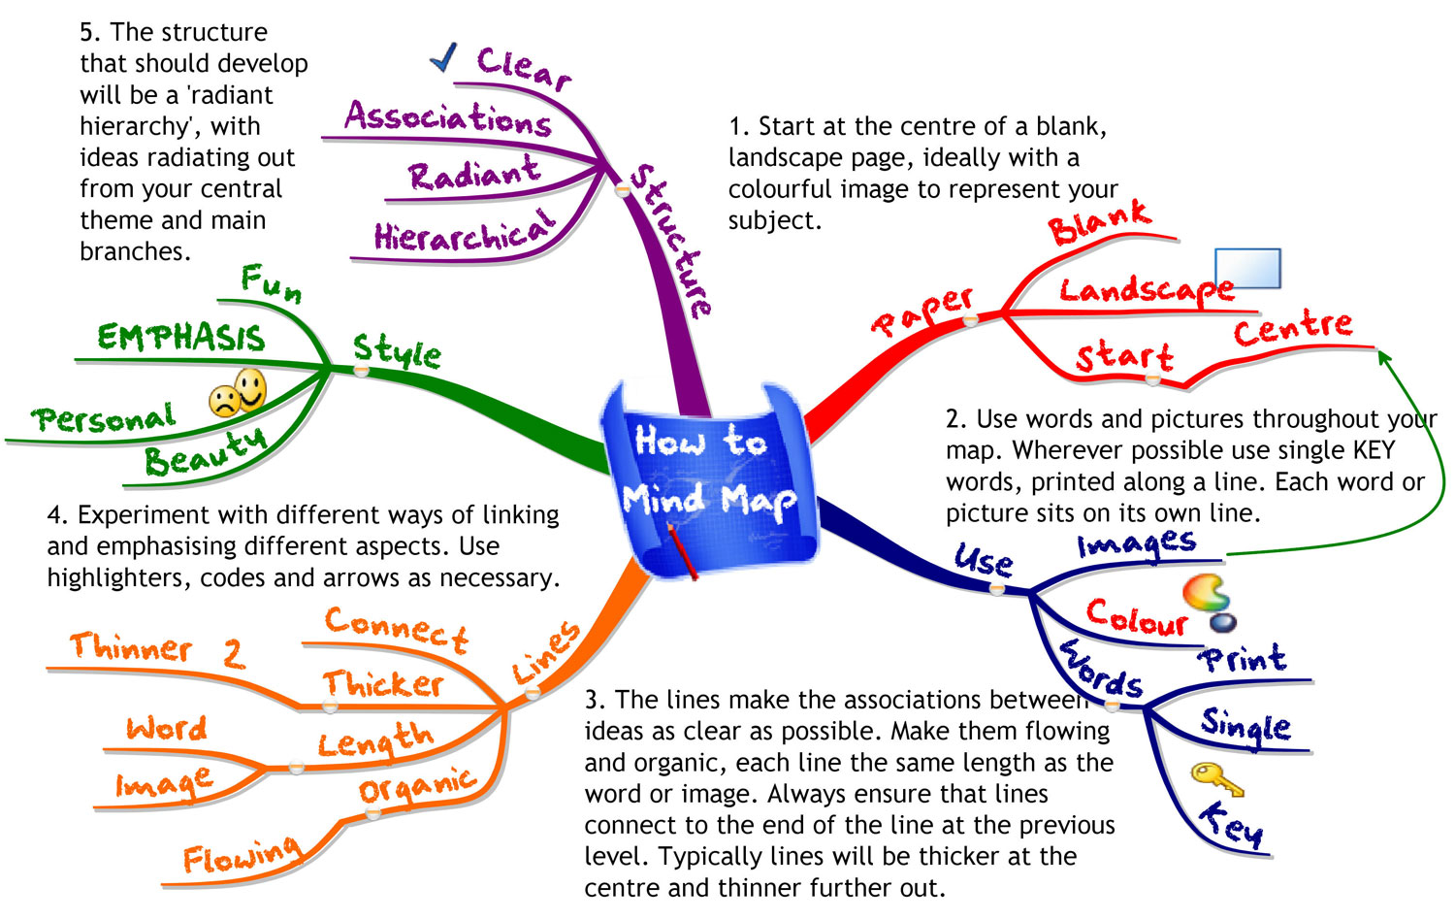
CUE CARDS
INSTRUCTIONS:
- On the first side of the index card, write a question.

- On the back of the index card, write the answer to your problem.
One way to enhance learning is to incorporate colour into the card-making process. If you are using flashcards to study a foreign language, for instance, you may use pink for feminine nouns and blue for masculine nouns.
You could also use colours to indicate regular and irregular verbs in foreign languages. Colour coding is especially helpful for students who are visual or tactile learners.

YOU WILL NEED:
- Cue Cards
- Coloured pens
- A topic to revise and the exercise and text books that go with it.

PLAY A GAME:
Using your Cue Cards you can challenge others to answer your questions. If they cannot answer them I enough detail you can TEACH them the answer.
TEACHING is a great way to learn!

SAMPLE CUE CARDS

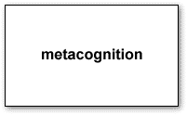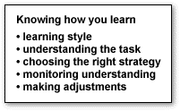

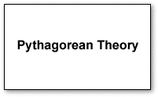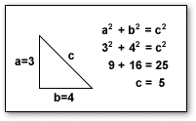

ANNOTATING TEXT
INSTRUCTIONS:
Unlike "highlighting," which is a passive activity, the process of annotating text helps you to stay focused and involved with your textbook. You'll find that the process of taking notes as you read will help you to concentrate better. It will also help you to monitor and improve your comprehension.
The following is a list of some techniques that you can use to annotate text:
- Underline important terms.
- Circle definitions and meanings.
- Write key words and definitions in the margin.
- Signal where important information can be found with key words or symbols in the margin.
- Write short summaries in the margin at the end of sub-units.
- Write the questions in the margin next to the section where the answer is found.
- Indicate steps in a process by using numbers in the margin.

EXAMPLE OF ANNOTATION
To annotate on Microsoft word use the ‘Review’ tab.

